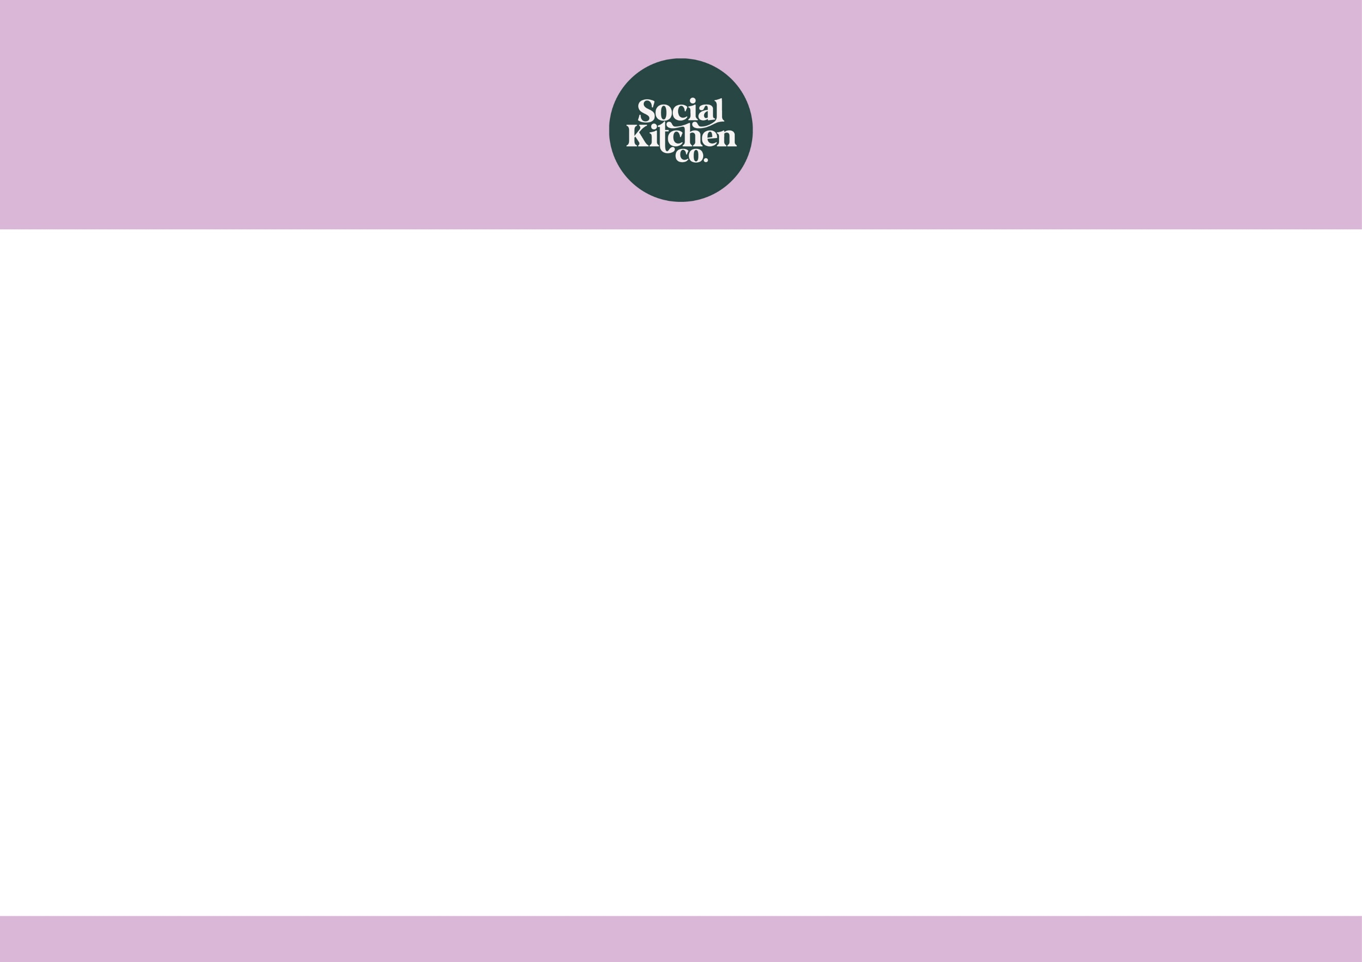
Choose any Simply Sandwich

Add a Traybake or a Small Jelly Pot

Add a Bottle of Water

£2.65
Sandwich Meal Deal

