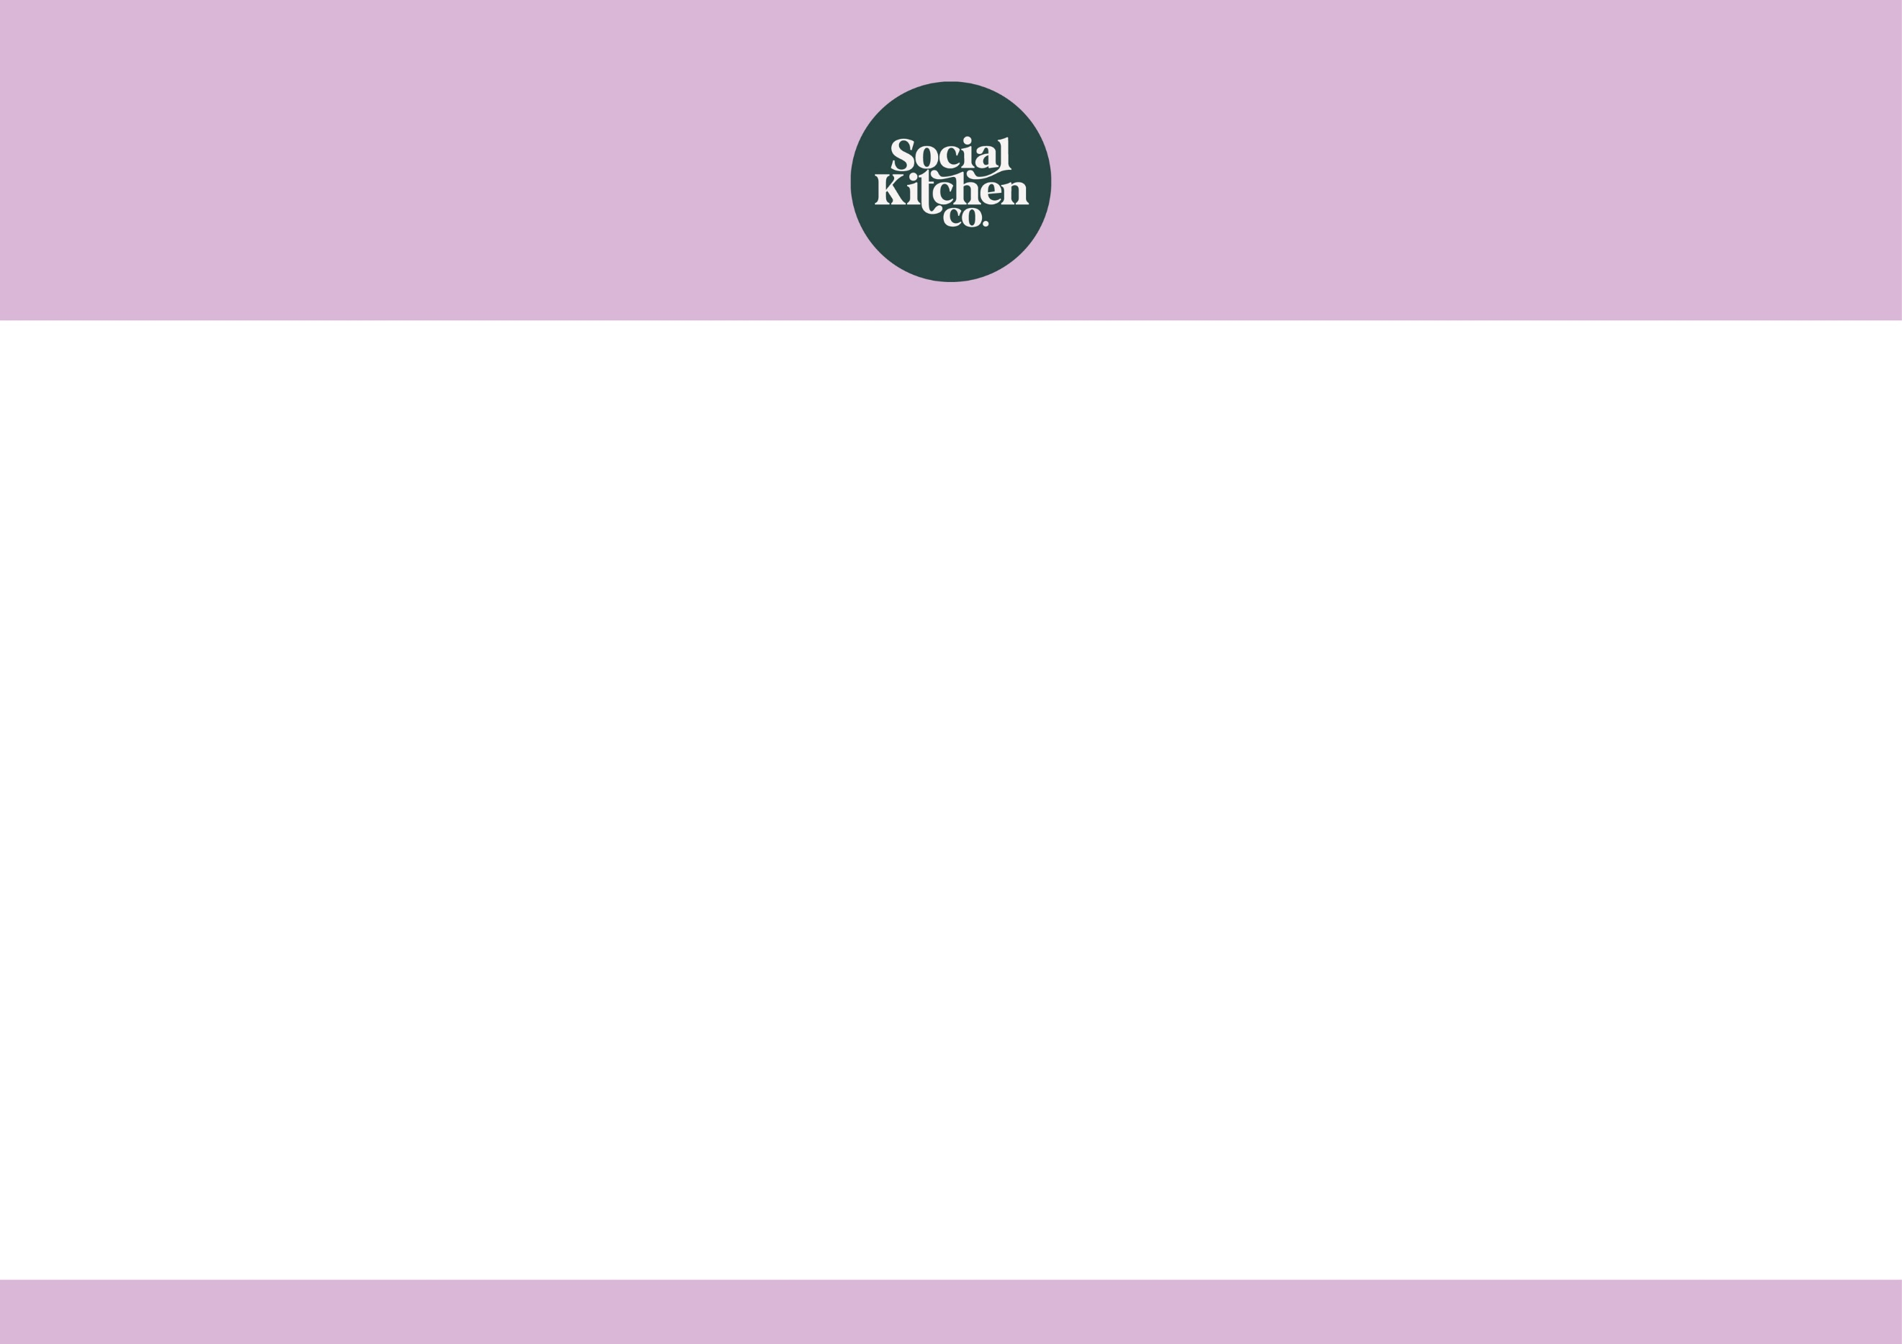

Jacket Potato
With
Baked Beans
OR
Cheese

Add a Bottle of Water

£2.65
Jacket Meal Deal

