Entering placement details on Grofar
- To start searching for opportunities on the system click the opportunities tab on the left-hand side. You can also search by company using the businesses tab.

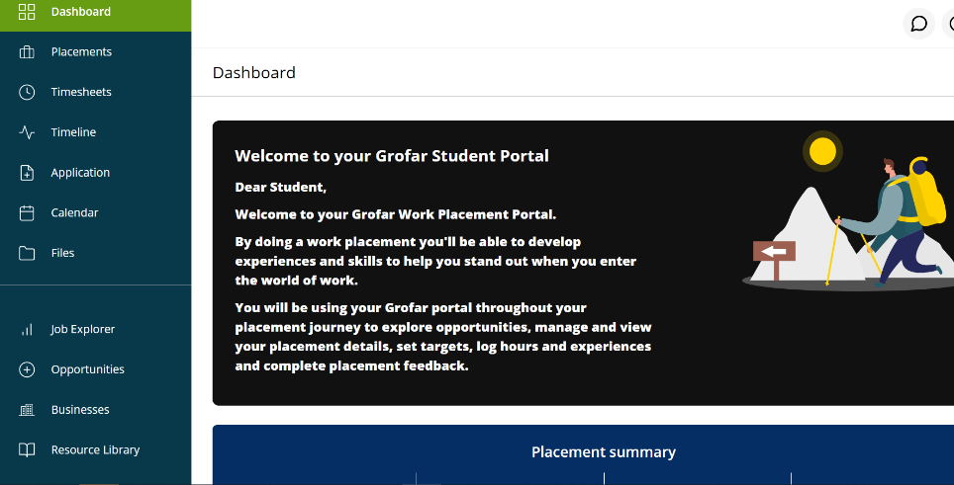

Opportunities

Business details

- This will take you to the opportunities page. you can search for opportunities to find out a bit more about the work placement. These opportunities have supported WEX in previous years.
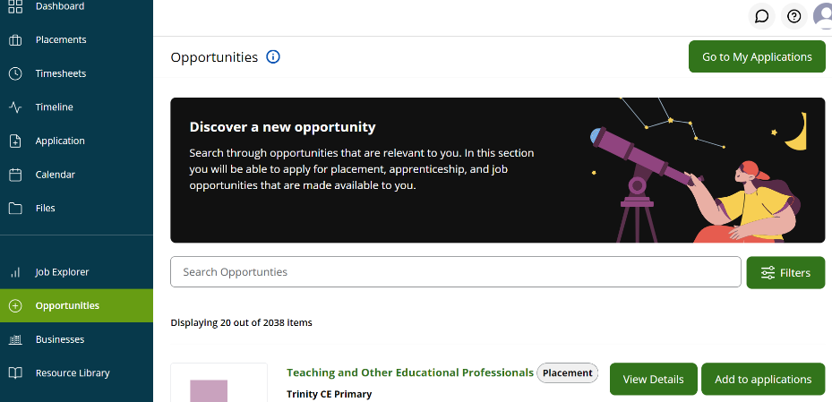

Use the filter option to narrow your search results.

- From your selection you can then look at the company details, find a contact name and email address for the company, you are also able to view google maps to find out where company is based.
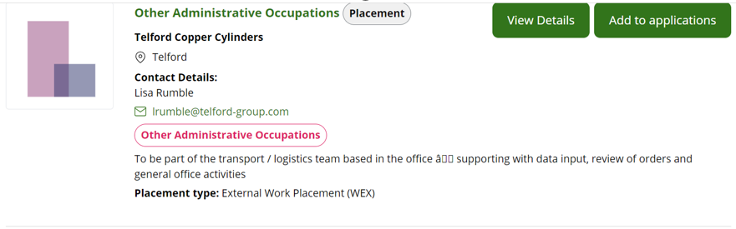
If you like the look of this placement, you can add it to your applications (wish list)
- All your potential placements will now sit in the applications tab.
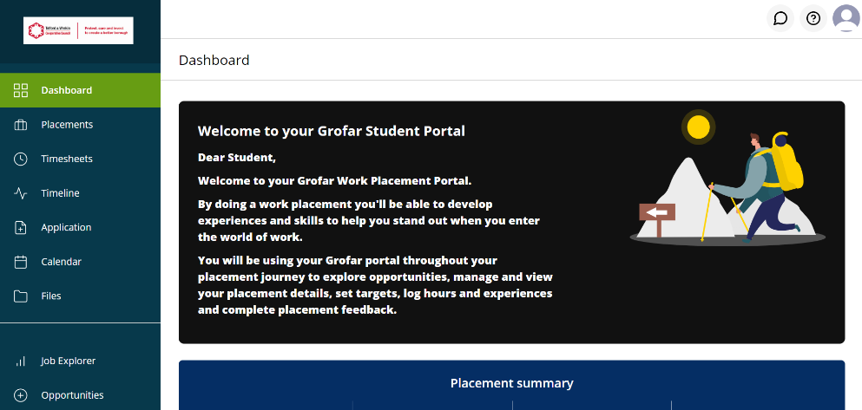

- Contact the company if you are interested to get further info by calling them or sending an email.

- Once you have had confirmation back from the employer that they are happy to take you on placement, remove the other opportunities until you are left with just the one you are interested and then select apply. This will then send your request to your tutor and the H&S team for checking.

How to apply for an opportunity that doesn’t exist on the database.
You may be accepted by a company that doesn’t exist on the database. For example, it could be a placement with a family members business. If this is the case, you can add this opportunity to the database.

- Simply Click the placements tab
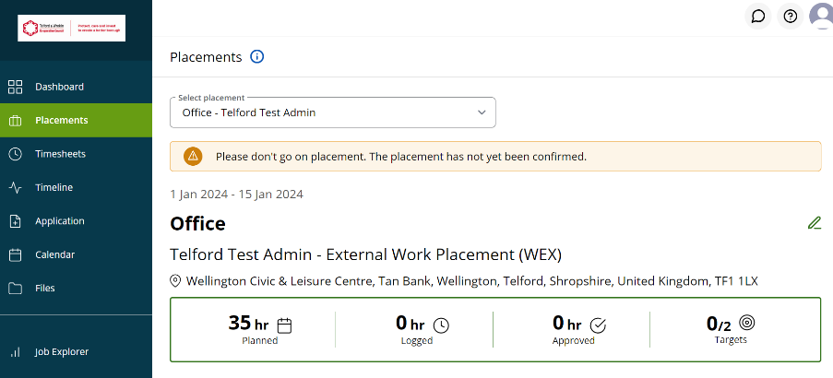
Then click on the little pencil icon (edit placement)

- Fill out the details of placement.
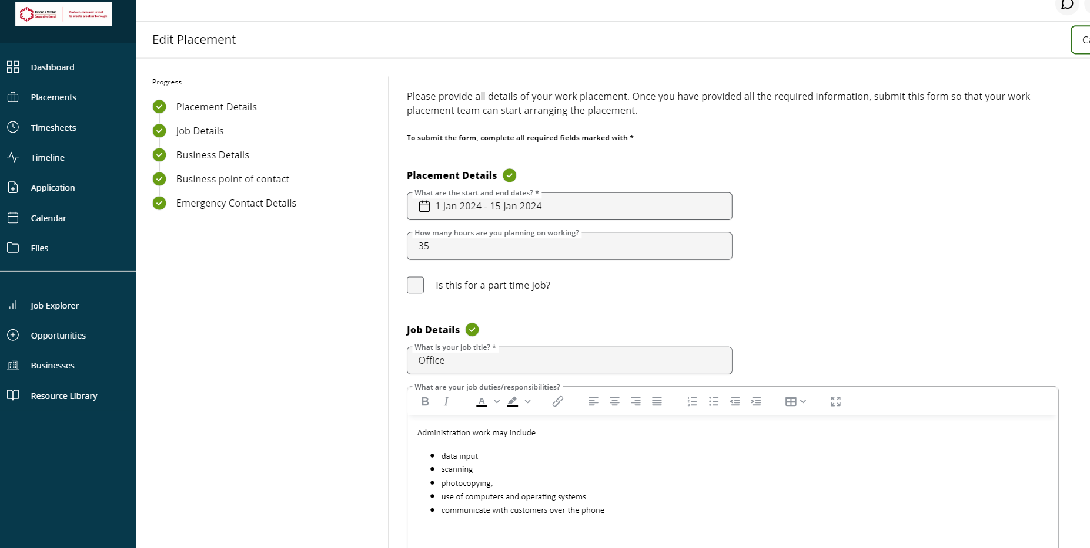
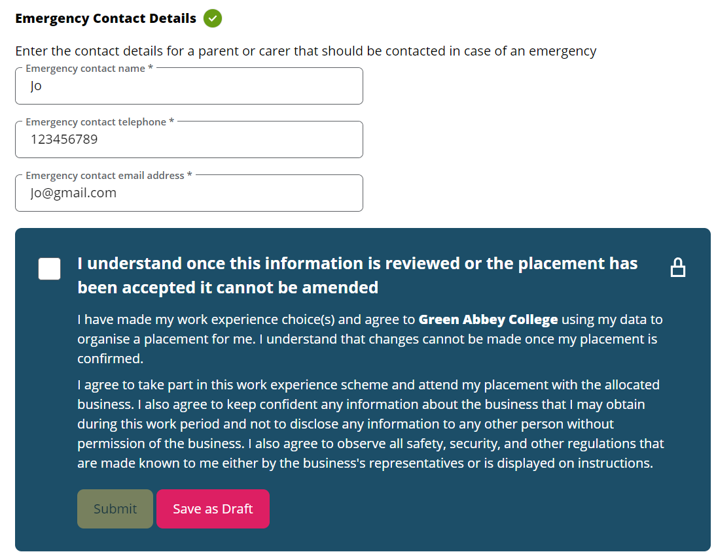
- Don’t forget an emergency contact person. This could be the school or your parents/carers.
Once completed read the statement and tick to say you understand. And submit. This will now go to your teacher for review.

- Help and Support:
- If you get stuck at any point, then Grofar has got a useful guide and videos on how to use the system.
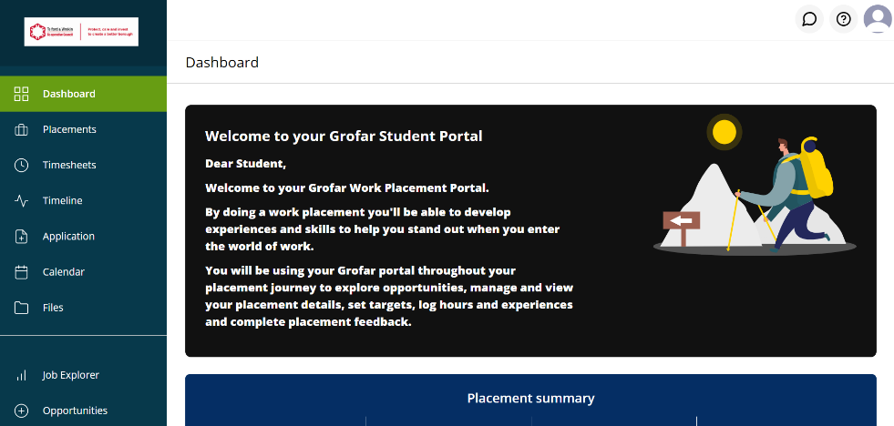

Or speak to the Careers and work experience coordinator in your school.

